Project Definition Document

Omiga Technology Refresh

Andy Green
Mortgages Software Delivery
Version 1.1
29 October 2007

For Circulation to:
Julia Murphy
Sue Craig
Gary Hammond
Georgina Cahill
Darren Eales
Martin Robson
Alasdair Cooper

© Vertex Financial Services Ltd 2007
The contents of this report are the copyright of Vertex Financial Services Ltd and all rights reserved. No part of this document may be reproduced, stored in a retrieval system or transmitted, in any form or by any means electronic, mechanical, recording or otherwise, without the prior written consent of the copyright owner.

Document control and record of amendments
Ver. no | Reason for amendment | Sections amended | Amended by/date | Reviewed by/date
0.1 | New document | All | Andy Green | Sue Craig 03/09/07
0.2 | Sue Craig Review | 1.2.4  2.3  3.1.2.1  3.1.3  3.1.4  4.1 | Andy Green  04/09/07 | Martin Robson  05/09/07
0.3 | Martin Robson Review | 2.2  3.2  3.3  3.4  3.5  4.2  5.2 | Andy Green  06/09/07 | Mark Gwilliam  07/09/07
0.4 | Mark Gwilliam Review | 1.4 New  3.1.3  5.1.2  5.3.2 | Andy Green  07/09/07 | Julia Murphy, Gary Hammond  10/09/07
0.5 | Julia Murphy & Gary Hammond Review | 1.2.2  3.13  3.2  3.4  3.5  6.3 | Andy Green  10/10/07 | Andy Green  10/10/07
1.0 | Business case sign-off achieved – document published for approval  Feedback from:  Julia Murphy  Georgina Cahill  Darren Eales  Ivan Kemp  Adrian Stanley | Various | Andy Green  29/10/07 | Julia Murphy  29/10/07
1.1 | Update version in footer  Add comment re Vista | Footer  1.4 | Sue Craig  10/03/08 | Julia Murphy  10/03/08

Contents
1. Introduction 4
1.1 Purpose of this document 4
1.2 Background 4
1.3 Project environment 7
1.4 Target Production Environment 8
2. Project Aims and Objectives 9
2.1 Aims 9
2.2 Objectives 9
2.3 Critical success factors 9
3. Project Scope 10
3.1 System Scope 10
3.2 Key Exclusions from Scope 12
3.3 Constraints 14
3.4 Assumptions 14
3.5 Dependencies 16
4. Project Organisation 17
4.1 Project Management structure 17
4.2 Project roles & responsibilities 18
4.3 Other key project Stakeholders 22
5. Project Approach and Lifecycle 23
5.1 Delivery strategy 23
5.2 Project phases 23
5.3 Development methods 23
5.4 Testing strategy 23
5.5 Organisation Change Management 23
6. Milestones, costs and risks 24
6.1 Delivery Schedule 24
6.2 Project costs 24
6.3 Risks 26
7. Project Management 29
7.1 Project planning and schedule control 29
7.2 Financial Control 29
7.3 Issue Management 30
7.4 Risk Management 30
7.5 Configuration Management 31
7.6 Change Control 32
7.7 Quality Management 32
7.8 Defect tracking and reporting 34
7.9 Communication 34
8. Project Documentation 35
8.1 Key documents 35
8.2 Document control 35
Appendix 1 – Technical Architecture Document 36
Appendix 2 – Product Management Programme High Level Plan 37
Appendix 3 - Omiga Technology Refresh Project Test Strategy 38
Appendix 4 – Omiga Product Management Programme High Level Plan 39

Introduction

Purpose of this document
All activities undertaken by Vertex Financial Services are subject to the company quality policy and the standards and procedures to be followed in general are described in the company Quality Management System (QMS).
The purpose of this Project Definition Document (PDD) is to define the scope, approach, time-scales, resources, responsibilities and quality activities for the Omiga Technology Refresh project. The PDD takes precedent over the QMS, but where standards and procedures are not defined within this PDD then the QMS will be used.

Background

Omiga Application
Omiga is the industry leading independent point of sale and mortgage application processing solution used by a number of leading UK mortgage lenders, including BM Solutions, Mortgage Express, Deutsche Bank, ING Direct and Northern Rock.

The last technology refresh took place in 1999 through 2000 with a comprehensive re-write of Omiga onto VB6. Since 2003 we have been aware of plans to replace VB6 and C++ with the .NET equivalents and we have elected to follow a step-by-step migration path supported by customer investment. Over the last few Omiga customisations we have made a number of steps forward with regards to the Omiga technical architecture in particular with the development of Web Services and the use of C# for new (and suitable) components.

We have now reached a stage where a wholesale migration / re-write of the remaining VB6 technology is required. In doing this we fully expect to take advantage of the knowledge and experience of other areas of the business (such as The Exchange and 1st Software) as well as being able to utilise existing components of collateral to reduce our overall development time.

Omiga is currently built around the Microsoft Windows DNA architecture largely using VB6, which officially goes out of Microsoft extended support in April 2008. The move to a .NET technology base is imperative for the continued future success of the mortgage software and outsourcing business. We are receiving clear messages from both existing clients (ING) and potential clients (GMAC) that they require Omiga to move off the unsupported VB6 development toolset in 2008. Nationwide have decided to go with a competitor product which is being marked as leading edge technology and more flexible due its use of SOA. These same points were also made by Lehmans – an opportunity we lost in Q4 2006.

Migrate or Re write ?
Research has been completed together with Microsoft, Independent consultancies, and elsewhere in Vertex (Prime, Exchange and First) to ascertain whether a wholesale migration, wholesale rewrite or simply do nothing would be the best approach. The approach to this research, analysis and strategic direction is detailed in the VFS Mortgages Omiga.Net Roadmap held in Migration to DotNet VSS under $/Port / Management / OmigadotNET roadmapv0 5.doc

The approach agreed is a combination of migration and rewrite, to refresh the Omiga technology removing completely the obsolete VB6 technology and re-writing of key components in phases to an SOA end state architecture.

An activity was progressed through Q2 2007 to prove the concept of migrating the existing Omiga VB6 code to C# via an automated conversion tool followed by minimal manual intervention. The Terms of reference for this activity are held in the Migration to DotNet VSS under $/Port / Docs / C# Migration POC TOR.doc. Whilst this activity was not completed, as it was superseded by our introduction to Microsoft's preferred supplier of worldwide upgrade services specialising in migrations to C# with a proven track record in migrations from VB6 to C#, a cut-down proof of concept was completed through a complete slice (middle tier to data layer and back) of the OmCrud component with satisfactory results.

This project is running in parallel with activities outside of the scope of this project, within the Product Management Programme, to:
- Document end-state Omiga architecture
- rebase ING and deliver into the mainline
- establish automated testing through the set up and proving run of Compuware,
- Define 100% functional test coverage, current and required functional test scripts, and automate
- establishment of a base product through a 3 phase approach (phase 1 of which has approval, most of which is being delivered in the ING project (mentioned in 1. above)
- Produce product policies and procedures

For the programme brief please see section 1.2.6 and for programme structure and details of each of the project deliverables, please see section 4.1

Artinsoft Consulting Services (AiS)
AiS are Microsoft's preferred supplier of worldwide upgrade services and were provided to Vertex through our Microsoft Application Development Consultant, Pedram Razeai.

A Terms of Reference was provided to AiS in April 2007 to describe the requirements for AiS to migrate the Omiga Visual Basic 6 source code to C#. The Terms of reference for this activity are held in the Migration to DotNet VSS under $/Port / Docs /Artinsoft /Artinsoft Omiga VB6 to C# Migration ToR.doc.

Working to this Terms of Reference, AiS performed a 22 day analysis exercise at Vertex Cheltenham and in their own offices in Costa Rica, consulting with Vertex staff to:
1. diagnose the current state of the system towards an eventual migration to the C# .NET platform and
2. propose migration alternatives
3. provide estimates for consideration
The output from this exercise was the AiS Ready Assessment document which outlined 2 approaches to migration based on delivery alongside the customisation of Omiga for Nationwide, which was being bid for at the time of assessment, together with estimates for Vertex consideration.
Following the loss of the Nationwide bid AiS were asked to consider their approach to migration, the result being to continue along the lines of their migration approach 2, albeit without the need to provide code back early for client customisation.
In summary, the AiS Ready Assessment document provides a proposal for a migration project to C# functional equivalence together with performance testing and tuning consultancy. No re-architecture is included in the proposal.
Functional Equivalence is defined by AiS as “ An application that implements the same business processes as another application while retaining the same behaviour to the maximum extent possible. Usually one application is the source for the other.”
AiS have provided a fixed price, fixed timescale migration of the Omiga middle tier components proposal for $699,900 (Option 2), based on a Lines of Code (LOC) as detailed below:
Priority Group | Visual Lines | Code Lines | Comment Lines | Blank Lines | Effective Lines of Code
Client | 0 | 456,261 | 108,905 | 167,638 | 456,261
Core | 300 | 160,580 | 45,093 | 18,305 | 160,880
Total | 300 | 616,841 | 153,958 | 185,943 | 617,141

The AiS Ready Assessment suggested Vertex undertake some code change to prepare for migration such as code ‘fixits’ from a code advisor tool run, error handling changes (for detail see Ready Assessment document). This code change, together with movement in the code since AiS vetted the product mainline will result in an AiS ’Rebase’ of the LoC count prior to work starting. This ‘Rebase’ is the key dependency on agreement to the current fixed price and timescale.
AiS will accept a 5% variation to the LoC before change control will be required against the fixed price and timescale. Changes will be impact assessed individually and scheduled together with AiS. Change Mgt: 5% change of LoC

Reference site visits
Financial and legal due diligence is being progressed through the Legal and Commercial department. An exercise of supplier technical due diligence was progressed through June and July. A reference sit visit was completed of Exchanging based in London, a conference call was completed with Sogeti, USA and Artinsoft visited the Vertex headquarters.
- Xchanging – for minutes of the reference site visit please see document held in Migration to DotNet VSS under $/Port / Docs /Management / 070614 Xchanging reference site visit.doc. In summary: the overall the project was successful; AiS ported 70,000 lines of code from VB6 to C#; AiS classed this project as medium complexity (the same judgement they have made of Omiga).
- Sogeti/Netjets - for minutes of the reference call please see document held in Migration to DotNet VSS under $/Port / Docs /Management / 070706 Songeti_Netjets Reference site conference call.doc. In summary: the overall the project was successful; AiS built a custom migration tool and provided it to Sogeti to migrate Netjets system (1 million LoC); AiS provided consultancy and training to the Sogeti/NetJets staff; Sogeti/NetJets re-architected their solution and built a framework prior to conversion to allow them to remove legacy components and build to industry standard design patterns. Artinsoft then customised the conversion tool to convert from the original VB6 into C# using the framework. This was seen as a longer riskier approach balanced by more advanced end state architecture.
- Artinsoft Visit – for minutes of visit please see document held in Migration to DotNet VSS under $/Port / Docs /Artinsoft / Minutes of Artinsoft Meeting 20080628.doc. In summary: the meeting was used to discuss process to full engagement, methodology and artefacts, functional equivalence and current issues around infrastructure. This meeting was the catalyst for more regular and detailed engagement, resulting in a draft AiS Statement of Work (SOW) and commercial agreement being delivered to Vertex for mark up, should the business case be approved.

Project Benefits
The Business Case for the Omiga Technology Refresh Project is held in Migration to DotNet VSS under $/Port / Management / NET Paper 180707 (Draft Business Case).doc.

The project will deliver, as part of the overall product mgt programme, the following benefits:
- A strategic solution capable of implementation for future customers.
- An upgrade path for existing customers such as DBM, ING and BM Solutions
- Better collaboration across development teams through the use of new development tools for .NET
- First cut of the framework for working in a product environment, covering procedures (remainder to be delivered out of the “Processes and procedures” project as part of the overall Product programme)
- Re-architected Supervisor

Project Funding
The project will be funded internally by the Vertex Mortgages Software Delivery business unit capital expenditure budgets for 2007/8 and 2008/9. We expect to recoup the cost of migration through future sales.

Product Management programme.
The Omiga Technology Refresh Project forms part of the Omiga Product Management programme.

The Product Management Programme Vision is:

“To increase the ability to share enhancements to Omiga across multiple customers and reduce the effort and time it takes to implement these enhancements supported within a .Net framework. “

The Product Management Programme Mandate is:

“A base product Omiga system will be established from the Epsom Release 2 version and converted to a .Net framework. This should include making this version able to be used by other future customers using configuration or 'switches' plus include the high priority functional requirements identified from the ING system. DB and ING are the only existing customers identified as being on Product. Future customers will need to be identified as either Product or Customised prior to contract. It is expected that customers on Product will have elements of the system which are customised and it is not expected that 100% of the system will be common code. All changes made to any customer on Omiga 4 (BMids, BBG, ING, DBM) will be reviewed to assess whether they are suitable product enhancements. If changes are deemed as product enhancements then where possible the changes will be designed and built in such a way that they can be configurable and therefore available in the Product. Customers on Product will need to take regular updates of the system which include these enhancements. Processes and procedures covering the whole lifecycle need to support this strategy.”

The Omiga Technology Refresh Project will deliver a .Net version of Omiga to the Product Management Programme together with a re-architected Supervisor tool (see section 2.2 for comprehensive list of project objectives).

Project environment
The technical environment for the Omiga Technology Refresh Project is defined in the DotNet Migration Technical Architecture document held in Migration to DotNet VSS under $/Port / docs / DotNet Migration Technical Architecture.doc

This document is presented in Appendix 1, and covers the following:
1. Vertex Development Environment
3. ArtinSoft Development Environment
4. Vertex Build Environment
5. ArtinSoft Build Environment
6. Vertex VB6 System Test Environment
7. Vertex .Net System Test Environment
8. ArtinSoft .Net System Test Environment
9. Non-Functional (Load) Test Environment
10. Business Continuity
11. Version Control
11.1. Hosted Version Control
11.2. Local Version Control
12. ClearCase Workstreams
13. Managing Change During Migration

Target Production Environment
The production environment being targeted by the Omiga and Supervisor development efforts is summarised as follows:

 | Layer | Purpose | Version(s)
CLIENTS | Web client | Access to Omiga | MS IE 7 browser
CLIENTS | Web client | Supervisor application | MS Windows XP / .NET 3.0  MS IE 7 browser
SERVERS | Web server | Hosts Omiga  web site | MS Windows 2003  MS.NET 3.0  MS Internet Information Services 6.0
SERVERS | App server | Supervisor services  Omiga components | MS Windows 2003  MS.NET 3.0
SERVERS | Database | Data store | MS Windows 2003  MS SQL 2005

The table above relates specifically to production environment. The versions of development tools required to deliver to this production environment are specified in the Technical Architecture estimates.

Vista is not being targeted at time of writing this document.

Project Aims and Objectives

Aims
To refresh the Omiga technology removing completely the obsolete VB6 technology, rearchitecting Supervisor and migrating the UI to ASP.Net.

Objectives

- To deliver a version of Omiga on a baseline determined by the project board, to functional equivalence, which operates on supported Microsoft technology (C#).

- To redesign Supervisor to take advantage of new technology, re-implement chosen existing business functionality, consider business enhancements whilst improving look and feel of the U.I.

Critical success factors
- Existence of a version of Omiga at project completion that is on supported technology
- Existence of supervisor services at project completion
- Existence of improved supervisor U.I. look and feel at project completion
- Existence of non-functional and performance test scripts for the Product code base.
- Existence of the manual functional test scripts, for product, that can not be run through Compuware
- Existence of a version of Omiga that is utilises ie7 and SQL2005.

Project Scope

System Scope

Set Up Product Ph1
The Rebase ING to Product project which forms part of the Product Management Programme is delivering all of the Set Up Product Ph1 scope, apart from the following (as confirmed by Mike Miller), which will be delivered in this project:

Action required | Description | Code & U/T Effort  ( Days )
Correction to Base | Tidy up' Look and Feel | 5
New Base functionality | IE 7 Support | 3
New Base functionality | SQL 2005 on Omiga and Supervisor | 3
New Base functionality | Omiga on .Net framework 2.0 | 2
Total |  | 13

Note: The task to Split BFS into functional areas, which is detailed in the Set Up Product Ph1 scope, will be deferred to a later phase of that project.

Set up Product Ph2 and Ph3 will be delivered within the Product Management Programme within the Set Up Base product project (i.e. it is outside of scope of the Omiga Technology Refresh Project).

Omiga4 Migration from VB6 to C#

Vertex Scope

- Set up and manage technical infrastructure, including dev, build and test environments for VFS. Support AiS set up and maintain environments in Costa Rica.
- Take delivery of the Product code base from the “Rebase from ING” project
- Define rules, best practice and guidelines for ported code (Cook book)
- Migrate U.I. from ASP to ASP.Net
- Migrate existing C# code to .net 2.0 (currently on .net 1.1)
- Code Preparation in line with AiS Ready Assessment (e.g. error handling, common code, shared library etc)
- Baseline code for AiS, agree SOW + commercials and manage change to baseline
- Migrate and optimise OmBase (using Netcoole Software’s migration utility)
- Integrate Microsoft Visual C++ 2005 ALPHACALCS component
- Merge duplicate versions of Shared Code components and re factor
- Identify Non Functional Test requirements, develop scripts and execute
- Prepare and execute performance test & benchmark pre migration. Re-run performance scripts post migration, tuning performance where required.
- Take delivery of functional test scripts from the “Set up automated functional test scripts” project which is part of the overall Product Management Programme.
- Prepare test scripts and perform test execution for the ‘manual’ functional tests – automated and manual testing to be defined and work estimated.
- Deliver C# code back to product mainline code stream and regression test

AiS Scope

AiS Scope is described in full in the Statement of Work which forms part of the contract. A summary is detailed below:

- Review fixed price and fixed timescale against revised Omiga baseline and agree SOW and commercials
- Migration of 77 Omiga ‘projects’ or ‘middle tier components’ (see Ready Assessment for detail)
- Migration of Data Access Technology from ADO to ADO.Net
- Replacement of other COM controls and components where possible
- Migrate XML processing code from MSXML to System.Xml
- Change native VB6 namespace functions to .Net functions
- Use of Shared classes instead of modules
- Error handling conversion modifications
- Functional Equivalent Omiga in C#
- Consultancy in support of performance tuning post migration

Supervisor Technology Refresh & Re-architect
- Supervisor Proof of Concept Proposal
- Supervisor Proof Of Concept, technical scope and estimates for full refresh & re-architect
- Scope and design documentation for improved look and feel of U.I.
- Evaluate 1st Software .net U.I. framework (FNET) and provide recommendation on whether it can be used for Supervisor application development
- Review Supervisor business enhancements document, estimates and priority afforded by the Design Authority and agree which enhancements are included in scope of this project
- Presentation of solution to Mortgages team for review and acceptance
- Supervisor analysis & design
- Supervisor re-architect of existing functionality
- Develop Supervisor business enhancements (once agreement reached on in-scope enhancements)
- System test
- Performance test
- Adoption of unit testing strategies and test driven approach to development
- Deliver back to product mainline code stream and regression test reimplementation of existing functionality in new technology
- Consequential Omiga code change and stored procedure changes

The diagram below illustrates the Omiga Technology Refresh high level products in the context of the Product Management Programme:

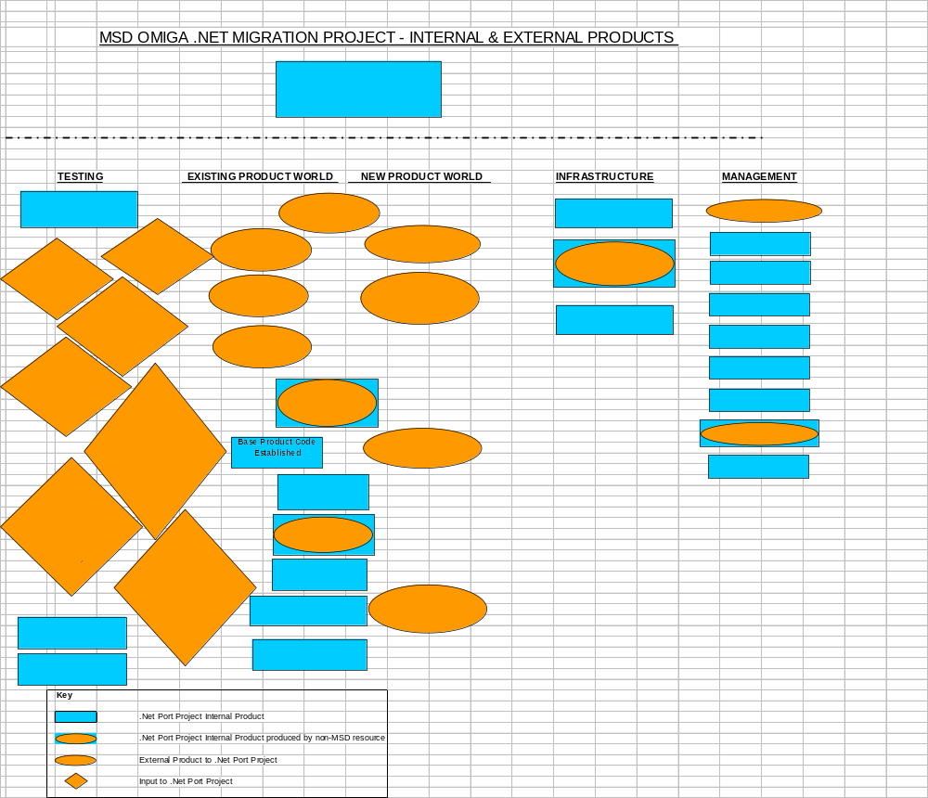

Key Exclusions from Scope
- Omiga4 Database redesign. The schema will remain the same.
- Omiga4 U.I. redesign. The U.I will look the same.
- Deutsche Bank Internet web site (already written in .net)
- Optimus
- Change Management activities (i.e. training)
- .Net coding standards/practices
- Identifying current functional test scripts/coverage against the Omiga4 product
- Setting up automated / optimised functional testing capability
- Developing 1st Software’s FNET framework to ensure it is fit for Omiga application re-architect
- Targeted performance improvements.
- Searching market for migration supplier and due diligence of chosen supplier (AiS already chosen)
- Functional Equivalent of ING features/code that can only be proven in an ING configuration of Omiga. Product features migrated and not proven within this project are detailed below.
- Artinsoft testing against (some) actual interfaces - Whilst the starting point will be testing product against actual interfaces, an exercise is underway to understand whether a number of test stubs will be required for Artinsoft to test to functional equivalence. Test stubs will be created and baselined where appropriate.
- That C# components can be deployed piecemeal to clients without complete C# implementation (apart from Core components and Supervisor)
- The development required to switch on the following Product features in the build of product:
- First Title Suite of interfaces:
- Esurv
- Hometrack (AVM)
- External PAF calls (UniServ)
- External Bank Wizard calls.
- Take Card Payment
- Security
NT Authentication
- Silent Logon and Launch (no screens used for this)
- Esurv Poller
- First Title Poller
- Full CRM (get Customer) Sync. present within Customer middle tier).
- Delay Completion
- Post Completion Task processing for Return of Funds
- Security update interface
- Pin Mailer Interface
- Completion Date and Payment type validation
- Task functions such as Change of Property
- Pack processing from single task etc
Task interfaces like (exhaustive list sought from Design Authority):
- RunRiskAssessment (the standard interface, Epsom have their own version)
- RunHunterInterface (original style)
- RunExperianHunter
- RunXMLExperianInterface
- UpdateCRSCustomer
- RunXMLExpUpdateLim (experian interface)
- RunGetCustomer
- UnapproveApplication
- SMSFulfilmentExtract
- EmailFulfilmentExtract
- RunEmailSMSInterface
- RunKnowYourCustomer (Epsom one would be better anyway)
- Valuation Rules component (Not used by Epsom)
- Remodel KFI
A number of Web services not used by Epsom where the middle components will be ported (exhaustive list sought from Design Authority):
- Stop And Save AiP
- Register Document To Case
- Get Document List
- Get Document ID
- Launch services

Constraints
Constraint | Consequence
- Time : Microsoft Visual Basic 6 IDE Custom Support completes 8 April 2008 | Target date for implementation of project is short enough to result in strategy being migration with some re-architect rather than full re-architect.
- Supplier: AIS has been chosen for the migration of Omiga middle tier components | Any further work to justify this supplier or look at alternative suppliers will impact cost and timescale
- Fixed Budget : the budget has been set to deliver the tasks as set out in the plan in Appendix 2 without having proven that the majority of the work in scope will fit into budget. | Need to manage budget in such a way that we need to monitor and report regularly against budget and scope.  Adopt an approach which requires us to obtain confidence in budget.  Need to be able to plan for iterative development in order that something(s) can be delivered if budget insufficient to deliver complete scope.
- Resource : Limited resources available in the department today (in particular testers) most of whom are deployed on other work

- Resource : suitable resources being available in contract market in time

- Day Rate : Steve Gledhill has used a day cost rate of £220 per day. | Tracking spend will be based on £220 per day. If any overheads are added to rate used to track spend, budget will be impacted.
- AiS Availability : to commence work in line with the Ready Assessment document | Once business case signed-off the milestone in the plan to provide AiS will the code to commence migration may be impacted by AiS availability, which in tern may impact cost and timescales.
- Supplier Contract : with AiS is fixed time and fixed price subject to 5% variation. | Plan will be time constrained rather than resource constrained.  Potential for AiS cost and timescale to increase which will impact business case, budget, plan and resource required.
- Project Milestones : the release plan being driven by Deutsche bank constrains timing of product and migration milestones, such as baseline activity. | Impact on control of migration together with introduction of need to work with increased external dependencies
- 1st Software FNET Framework : the Supervisor technology refresh will be implemented on the FNET framework | The requirement to identify issues with the framework and resolve.  The requirement to identify gaps in the framework and develop+test prior to supervisor application development.

Assumptions
Assumption | Consequence
- The code will be provided to AiS in Costa Rica to limit hardware costs and lead times together with remote access performance issues. Vertex staff at AiS will access Omiga VM over citrix via a specified URL where required | Should code need to stay onshore a minimum of an additional £100k hardware set up costs will be incurred (see Architecture doc); additional infrastructure lead times will be required. AiS fixed timescale and price is dependent on connectivity that performs to AiS’s satisfaction. Performance of connectivity is likely to require VFS SLA’s. The performance of connectivity can only be tested once purchased and implemented.
- Clearcase will have been reconfigured for ‘Product’ prior to the code being provided to AiS. | To allow the controlled provision of ‘product’ (DB) code and to limit the amount of code to be ported but not tested. Potential impact on AiS price and timescale.
- Ideally client acceptance (at least internal acceptance) of the technology refresh is accepted by the client and the need to keep code change to an absolute minimum | Impact on timescale and cost should a large amount of functional change need to be provided to AiS for rework, or should it need to be developed in VB6 and subsequently again, in C# on return of code from AiS.
- The Capex and Opex (detailed in section 6.2 Project Costs) has been approved within the business case therefore procurement do not need Capital Approval request forms at time of purchase | Impact on project milestones
- Compuware will have been implemented into the department and ready for use by the project | Impact on cost and timescale as no testing will be automated and therefore 100% manual at every test cycle.
- Test cases to prove functional equivalence can be added up to halfway through the manual migration phase | If milestone not hit, AiS fixed cost and timescale may be impacted. Overall project time and cost may be impacted
- Testing Omiga functionality through the GUI will touch all Product functionality (available in a DB configuration) | Testing gaps and/or additional work, cost, timescale.
- No implementations for new clients will be required until after the code has been returned and functional equivalence achieved | Need to change a major amount of VB6 code at time of migration and re-code in C#
- Training required to equip the department resources to develop the C# Omiga product will be delivered outside of this project | Training budget for department will need to be set accordingly, appropriate courses identified and booked time
- The activity to deliver coding standards for C# and .net development resides with the programme under the policies and procedures project. The Omiga Technology Refresh project may have to create some standards where Supervisor C# development is required before the programme delivers. (Note: This project will deliver migration coding standards as in-scope project work). | The Policies and Procedures project needs to schedule coding standards for delivery before Supervisor development starts in C# - or impact cost and milestones where the Supervisor re-architect resources develop the required standards this project.
- Change to code required to ensure Omiga works with IE7 and SQL2005 will result in regression of Omiga product against current supported IE versions for Product clients (DB and ING) | Regression testing against ING screens or risk that product will be broken

Dependencies
The external dependencies that have been identified to date are:
Dependencies | Consequence
1. ING Rebase project development to deliver product features and switchable code to mainline prior to code provision to AiS | Code provided to AiS is DB code only and not product resulting in further porting at later date – potential impact on cost and timescale.
2. Fluid DB existing project schedule | Regular movement of key milestones impacting date code can be baselined and a work stream created for AiS OR  We remove the dependency – DB cut and run
3. Definition of ‘100%’ or ‘complete’ Product functional testing scripts/requirements | Potential for functional testing gaps – impact on cost and timescale should testing need to be revisited
4. Compuware set up and proven | Impact on cost and timescale as no testing will be automated and therefore 100% manual at every test cycle.
5. Definition of the functional testing that can be automated through Compuware together with functional test coverage to be automated | Unable to understand amount of functional testing, and functional areas which require manual test scripts. Unable to estimate manual functional testing effort required for preparation and execution.
6. Reorganised Clearcase structure | Retrofitting product code into different ClearCase structure than taken for migration work stream – impact on cost and timescale.
7. Code change for Re-architect cannot start until this project has delivered a proven C# Omiga to the product mainline | Rework, additional cost and timeline

Project Organisation

Project Management structure

The diagram below illustrates the Omiga Technology Refresh Project in the context of the MSD Product Management Programme:

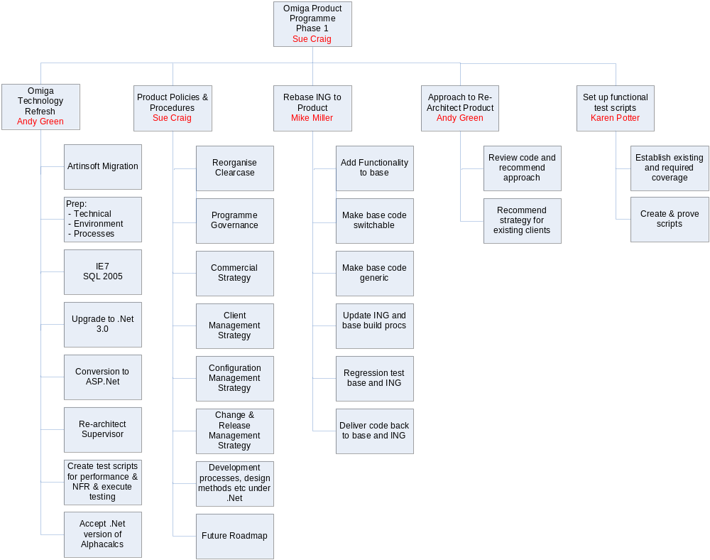

The diagram below illustrates the Omiga Technology Refresh Project Senior Management Organisation structure:

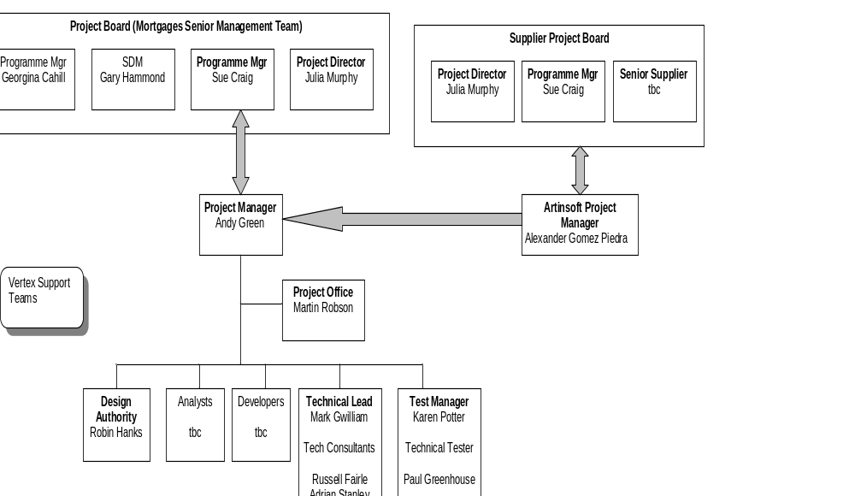

The diagram below illustrates the AiS Organisation structure:

To be added once confirmed.

Project roles & responsibilities

Project Board (Steering Group) - Mortgages Software Delivery Senior Mgt Team
- Responsibilities:
  - Provide overall direction and guidance to the project.
  - Ensure the project meets agreed standards of quality, time and cost.
  - Ensure that the project remains viable against its business case.
- Requirements:
Project Board members must have sufficient authority to commit the resources required by the project.

Project Sponsor (Julia Murphy represents Vertex board]
- Responsibilities:
  - To ensure that the system being developed achieves the expected benefits
  - To ensure that the business operations achieve the expected benefits
  - To ensure that the project is completed within the approved costs and timescales
  - To ensure that the Supplier meets their contractual obligations
- Specific Tasks:
  - Organise and chair Project Board meetings.
  - Authorise expenditure and maintain overall budgetary control.
  - Ensure that the overall project has objectives.
  - Confirm that all plans meet project objectives.
  - Monitor the continuing viability of the project.
  - Assign Client Project Manager.
  - Authorise the acceptance of the project and its systems.
- Requirements:
Understand the overall IT and business strategy for the project area.

Supplier Project Board (Steering Group) – Sue Craig, Julia Murphy & Senior Supplier
  - Provide overall direction and guidance to the supplier.
  - Ensure the supplier meets agreed standards of quality, time and cost as set out in the commercial agreement
  - Supplier issue resolution.

Senior User (Gary Hammond- ING and Darren Eales- Deutsche Bank)
- Responsibilities:
  - To represent the interests of the user departments(s) affected by the project
  - To 'own' the functionality of the system
  - To monitor progress against the requirements of user management
- Specific tasks:
  - Sits on Project Board
  - Agree objectives and quality criteria for the business aspects of the system
- Requirements:
  - Know the affected business areas well
  - Be aware of how the business will operate with the new system

Programme Manager (Sue Craig)
            - Responsibilities
  - To ensure that all projects in the programme are delivering on time and to expected budget and quality standards
  - To provide project manager with required number of sufficiently skilled resources on time
            - Specific tasks:
  - Sits on Project Board
  - Sets objectives and quality criteria for the project

Project Director (Julia Murphy)
- Responsibilities:
  - To ensure a mutually beneficial business relationship between Vertex Financial Services and the Supplier
  - To ensure that the project meet the agreed standards of quality, time and cost
  - To ensure that Vertex Financial Services meet their contractual obligations.
- Specific Tasks:
  - Direct the overall conduct of the activities
  - Sits on Project Board
  - Authorise Vertex Financial Services expenditure and maintains overall budgetary control of the Vertex Financial Services activities
  - Confirm plans meet the objectives of the project
  - Assigns a Vertex Financial Services Project Manager
  - Resolve conflicts related to Vertex Financial Services activities
  - Review and authorise resource assignments
- Requirements:

Project Manager (Andy Green)
- Responsibilities:
  - To ensure that the project as a whole produces the required products to the defined standard of quality
  - To complete the project within cost and time constraints
- Specific tasks:
  - Plan the project and agree the plan with the Project Board
  - Liaises with all other aspects of the project and associated/related projects
  - Define individual responsibilities for the VFS project team and ensure that the team has the necessary business and technical competence.
  - Agree reporting frequency with Project Board
  - Define and enforce project standards and controls for the client project team
  - Monitor progress of all aspects of project
  - Day to day direction of client project team
  - Review all related Change Controls and agree impact on project
- Requirements:
  - Appropriate level of management experience
  - Appropriate business and technical experience

Design Authority / Lead Analyst – Robin Hanks
Responsibilities:
- To 'own' the functionality of the system
- To ensure that the solution design meets the requirements
- Approve Functional Specifications
- Verify that Acceptance Criteria are consistent with project aims, objectives and agreed requirements
- Resolve conflicts in business requirements
- Review Change Controls and agree impact on project
- Sign-off acceptance documentation on successful completion of the system installation
- Brief and advise user management on all project matters
- To ensure that the developed solution is complete and meets the defined standard of quality, timeliness and cost
- To support the Developers in translating the specification into a design and then code
- To support the testers in the development of test plans and during System Testing

Project Manager (Artinsoft) – Alexander Gomez Piedra
- Responsibilities:
  - To ensure that the AiS project produces the required products to the defined standard of quality
  - To complete the AiS project within cost and time constraints
- Specific tasks:
  - Plan the AiS aspects of the project and agree the plan with the VFS Project Manager and Supplier Project Board.
  - Liaises with all other aspects of the AiS project, both internally and with Vertex Financial Services.
  - Define resource requirements and build a project team with the appropriate level of technical and business competence.
  - Define individual responsibilities for the AiS development team.
  - Agree reporting frequency with VFS Project Manager and Supplier Project Board and internally with AiS management
  - Define and enforce project standards and controls for the development team.
  - Monitor progress of the AiS aspects of the project.
  - Day to day direction of the AiS development team
  - Review all related Change Controls and agree impact on project.
  - Understand and operate project to terms of contract.
- Requirements:
Appropriate level of system development and management experience.

Project Leader / Project Support – Karen Potter (Testing)
Responsibilities:
- To ensure that the project meets its targets in terms of Quality, time and cost, as defined by the Project Manager
- To assist the Project Managers in the technical aspects of project management - e.g. constructing and progressing project plans and schedules, risk management, status reporting, budget control, document control etc.

Senior Technical - Mark Gwilliam
Responsibilities:
- To ensure that the project technical environment is suitable and stable
- To ensure that the system will meet its performance requirements
- To ensure the quality of the technical design
- To define and maintain configuration control over the technical environment.
- To control the build and release of system deliverables

Configuration Management - tba
Responsibilities:
            - Create work streams in ClearCase and VSS
            - Control deliveries to/from Artinsoft
            - Setting baselines in ClearCase and labels in VSS
            - Maintaining build scripts and install shield scripts
            - Managing integration of individual developers work to build

Quality Assurance
            - General Project Assurance – performed by the Project Office – tasks include quality assurance to the project board for plan, budget, and all general project controls
            - Technical Assurance – performed by the Design Authority and Senior Technical Consultant
            - Business Assurance – performed by the Design Authority and Senior User (Gary Hammond/Darren Eales)

Developer
Responsibilities:
- To ensure that all system elements developed meet the defined requirements
- To ensure that all system elements developed are to the defined standards

Tester
Responsibilities:
- To detect defects in the system and report findings in an appropriate manner
- To support Systems Analysts and Developers in the correction of defects.

VERTEX Support Teams
- Mortgages Finance support for financial control and planning
- IT Governance Architecture and environment design, estimates and central Vertex sign-off
- BTS delivery and maintenance of technical infrastructure
- Legal support for contract management
- OMIGA Project Office support for development processes

Other key project Stakeholders

1st Software
- Collaboration with 1st Software is being investigated in for Supervisor re write.
- Provision of knowledge from practical experience in developing with .net framework

Vertex Divisional IS & Transformation Director
- John Proudlock

Project Approach and Lifecycle

Delivery strategy

Omiga
            - The delivery of the C# Omiga will be a big bang delivery to the Omiga product mainline based on baseline taken x months ago in VB6.
            - Following 1st big bang delivery, a performance fix delivery will be provided to the product mainline 1 month later
            - 2 months after performance delivery C# change and defects (written to product sine migration) fixed into C# code will be delivered to the product mainline

Supervisor
The Supervisor re-architect will follow an iterative approach to development to provide early proof of new C# code and services and deliver a higher quality end result
            - 1st delivery is stand alone re-architected Supervisor proven against VB6 Omiga code
            - 2nd delivery is Supervisor working against C# Omiga code

Project phases

Migration: A waterfall principle will be adopted for the migration, however not all phases will be relevant.
Supervisor: An iterative approach to development will be adopted for supervisor with delivery to system test being divided into delivery of new services (split of services to be confirmed once scope agreed)

Development methods

Omiga
Please refer to the standard Mortgages Software Development lifecycle document.

Supervisor
Using a more Agile approach to development, testing and quality assurance, it will be possible to mitigate a large amount of risk around the user acceptance, regression, quality and timely delivery of the Supervisor deliverables

Testing strategy
Please see Appendix 3 for the Omiga Technology Refresh Project Test Strategy

Organisation Change Management
1. Training required and delivered outside of the project
2. Policies and procedures programme needs to be scheduled such that development processes and coding standards have been delivered before C# application is available for client customisation

Milestones, costs and risks

Delivery Schedule
The table below defines the key milestones, associated deliverables and target dates. Please see Appendix 2, the Project Plan for more detail. A number of the key milestones are based on assumptions at the time of writing this document and are subject to change.

Milestone / Deliverable | Target Date
- Project Start | October 2007
- Infrastructure and development environments set up | November 2007
- Commercials with AiS signed off | January 2008
- Omiga GUI Migrated to ASP.Net | November 2007  Decision taken 04/10/07 not to migrate pre-migration and revisit decision post Palmer decision
- Provide code to Artinsoft | February 2008
- Functional Test Scripts provided to Artinsoft (Automation) | March 2008
- Supervisor re-architect complete | July 2008
- Functional equivalence of Omiga in C# | July 2008
- Performance tuning complete | August 2008
- Product VB6 change Feb – July applied in C# to code | August 2008

Project costs

Product Management Programme Costs
The costs below represent the costs provided to Steve Gledhill for the Product Management Programme business case (also referred to as Project Hubble (Strategic Omiga Transition Programme). Note that £58k expenses has been excluded from the business case produced by Steve Gledhill resulting in the cost submitted to the Vertex Board being £1,688k. Please see Appendix 2 - Product Management Programme High Level plan for a breakdown of tasks and costs.

Product Management Programme Financials | Days |  | £
VFS Artinsoft Invoice |  |  | £ 352,000
VFS Labour cost (inc 30% contingency, 1204 days) | 5283 |  | £ 1,236,000
VFS Hardware cost |  |  | £ 100,000
VFS Expenses |  |  | £ 58,000
Microsoft | 15 |  | £ -
Total | 5298 |  | £ 1,746,000

All costs submitted for the Product Management Programme business case relate to the Omiga Technology Refresh project apart from those listed below (reference Appendix 2 for task No.):

HL Programme Plan Task No. | Task | Days | £
2 | Set Up Base product Ph1 (part ING/part this project see section 3.1.1 for detail) | 111 | 24,420
3 | ReBaseline ING (and regression test) | 100 | 22,000
34 | VFS Programme Manager | 200 | 44,000
32* | VFS Functional Testing | 600 | 132,000
48 | Policies & Procedures | 100 | 22,000
49 | Proposal & plan to Re-architect Remainder of Omiga | 200 | 44,000
Sub-Total |  | 1,311 | 288,420
 | Contingency at 30% | 393 | 86,526
Total |  | 1,704 | 374,946
* The assumption has been made that the remaining 400 days will be required in the Omiga Technology Refresh Project to:
            - prepare and execute all functional testing that can not be automated through Compuware
            - prepare and execute all non-functional testing that can not be automated through Compuware

Omiga Technology Refresh Project Costs
The subtraction of the programme costs provides for a project budget as set out below. Please

Omiga Technology Refresh Project Financials | Days |  | £
VFS Artinsoft Invoice |  |  | £ 352,000
VFS Labour cost (inc 30% contingency, 829 days) | 3578 |  | £ 787,212
VFS Hardware cost |  |  | £ 100,000
VFS Expenses |  |  | £ 58,000
Microsoft | 15 |  | £ -
Total | 3593 |  | £ 1,297,212

The Omiga Technology Refresh Project hardware/software cost requirements are broken down as follows. This is the only project within the Product Management programme that has such costs included in the Programme business case:

Omiga.NET Porting Infrastructure Costs | Capex | Opex
VFSD Build PC | £ 2,500 | £ 600
VFSD Developer PC - Post Port Development | £ 12,000 | £ 3,000
SAN - Space for SourceSafe and ESX Images | £ 9,000 | £ 2,000
Blade Infrastructure Requirements | £ 20,000 | £ 5,000
.NET DB Server | £ 6,000 | £ 2,000
Omiga Load Test Web, App and Ingestion | £ 10,000 | £ 2,000
ESX Farm | £ 8,000 | £ 2,000
Citrix Servers - Remote Access | £ 10,000 | £ 2,000
Networking | £ 2,000 | £ 2,000
Total | £ 79,500 | £ 20,600

Risks
Risks will be recorded in a Log and managed as described under the Risk Management in the next section. The most significant risks identified to date are:
Risk | Likelihood  H/M/L | Impact  H/M/L | Actions
- Key resources on the program leave the company leading to delays in the schedule |  |  | Contingency built into the programme.  Microsoft partnership contract is in place. Regular design reviews to be held with Microsoft and any involved partners.  Supervisor to be developed and used as a proving ground for the architecture.
- Use of new technology and approaches when developing Supervisor, yet to be fully proven in our commercial environment.  - Resultant problems could lead to code re-writes or late implementation of other technology. This in turn could cause a cost overrun and also cause the programme to overrun. |  |  | Strong project and configuration control to be in place as with other external development programmes.
- Scope creep or excessive demand for change leading to cost and schedule overrun. |  |  | Internal Governance to be given early notification of requirements. Regular meetings to be held with Internal Governance to enable early notification of changes
- Delays incurred from Internal Governance will lead to schedule delays and possible impact on overall costs. |  |  | Testing cycles to include a level of performance and concurrent usage. Performance testing will be undertaken on the live service before it is ‘switched on’.
- Performance of the new system is inadequate. |  |  | Need to fix it – cost and timescale impact
- The amount of functional testing coverage (scripts) available prior to the project is unknown – resulting in amount of work to do to achieve 100% coverage unknown |  |  | Project identified to:  1) Define 100% functional test coverage  2) Identify current script availability  3) Identify and develop outstanding scripts
- The amount of testing that can be automated through Compuware is unknown |  |  | Action identified and allocated to consult with Compuware and confirm which tests can be automated. Sizing of manual testing prep/execution can then be progressed.
- The budget has been set for functional testing before understanding how much work is involved |  |  | See 2 actions above. Estimates urgently required. 30% contingency added to project.
- The review of the 1st Software FNET framework identifies issues which are showstoppers
- The development required to fill the gaps identified in the FNET framework will result in impact to the critical path required deliver the Supervisor application in time with project milestones
- The learning curve required to understand the FNET framework will impact delivery of key Supervisor milestones
- A code freeze can not be achieved or implemented at all |  |  | Project budget has allowed for 400 days of code churn whilst code with Artinsoft, resulting in C# recoding post migration. Monitoring of code change and defect fixes to be put in place before whilst code with AiS.
- The Capex and Opex costs in the programme business case relate specifically to the Omiga Technology Refresh project – no other project Capex/Opex costs have been included |  |  | Specific monitoring of identified items to be put in place with Finance and regularly reported against.
- Only 1 resource is trained in Compuware. Set up automation of functional test scripts, maintenance of such scripts and execution is potentially the largest activity in the Omiga Technology Refresh project and the programme. It is also critical path for passing code to AiS. To have only 1 resource trained in this area is a risk to the project milestones |  |  | Training of staff required to provide required numbers of skilled resources urgently.
- Product Programme Governance not in place at outset of project - Impact on cost and timescales should Product Programme Governance impose additional requirements on the project |  |  | tbc
- Mortgages Software Development Product Programme Commercial Strategy not in place at outset of project - The recommendation of the Omiga end-state architecture and functionality will not be fit for purpose |  |  | tbc
- Product Programme Client Management Strategy not in place at outset of project - Additional cost and timescales should client demands impact deliverables/milestones of the project |  |  | tbc
- Product Programme Configuration Management Strategy not in place at outset of project - Additional cost and timescales should Product Programme Configuration demands impact deliverables/milestones of the project |  |  | tbc
- 12. Product Programme Change & Release Management Strategy not in place at outset of project - Change is not managed sympathetically to the migration timescales and deliverables resulting in potential additional cost and timescales |  |  | Tbc
- Vertex Due Diligence exercise concludes that we are prevented from engaging with AiS |  |  | Progress due diligence urgently.
- Use of rational Clearcase and Clearquest are not best available toolset for developing a in an agile way with Microsoft technologies. This toolset is inconsistent with other Vertex software departments which may impact ability to share source.

Project Management

Project planning and schedule control

Activity / task control
Prince II is applied to the development methodology, processes and procedures. Clarity (Workbench) is used as the project planning and reporting tool.

Project Reporting
Regular reports to be produced by the project include:
- Weekly status reports to the Vertex Financial Services Project Director
- Weekly status reports to the Project & Programme Board
- Weekly Status reports from AiS to VFS Project Manager
- Monthly status reports for the Vertex Financial Services Senior Management Team (co-ordinated by the Management Support Team)

Resource control
Resource requirements (staff) for the project will be defined in the project plan. Where such resource is not in place, a minimum of 6 weeks notice will be given to the Project Board for approval of relevant internal/external recruitment. Weekly 1:1’s with the Programme Manager and ad-hoc communications will provide the forum for managing day-to-day resource requirements.

New project members will be inducted through a ‘buddy’ system. Induction time for new project members will be captured under a separate plan task in Clarity.

Financial Control
A business case will set out the cost of the Product Management Programme which Vertex Mortgages Finance department will track, including supplier costs, hardware, software and expenses. This will become the budget against which financial tracking will be undertaken for the programme.

The Omiga Technology Refresh Project has set the budget for the deliverables into the Product Management programme. The Omiga Technology Refresh Project Manager will track actual and forecast days and cost against the project budget and provide a formal monthly report into the Product Management Programme Manager, Project Board and the finance department

A monthly face-to-face meeting the Finance Manager will be used to discuss this monthly report and ensure common understanding of all costs is achieved.

A weekly report containing the following will be completed and available to the Project Board:
- Actual days and costs compared with budget
- Estimated days and cost to completion compared with budget
- Total forecast days and cost compared with budget

A contract will be agreed between Vertex and AiS for their deliverable of migrated Omiga C# code that is functionally equivalent to the code provided in VB6. The current draft payment schedule suggested by AiS is (and to be agreed contractually):

VFS Payment Schedule for Omiga Migration
Deliverable | Price | Date
VBUC License | $89,999 | Project Start Date
VBUC Customization and Omiga Green Code | $27,798 | 1.5 months after Project Start Date
Compiling Source Code | $232,841 | 2 months after VBUC Customization
First Application Build for QA | $116,421 | 1 month after Compiling Source Code
Functional Equivalence | $232,841 | 2 months after the first Build for QA has been delivered
Total | $699,900

The APLHA calculations component will be re architected in C# at the cost of the Life, Pensions & Distribution business unit. This project will track the days and cost required by the Mortgages business unit to integrate and test Omiga against the APLHA C# interface.

Issue Management

Issue tracking
Project issues will be tracked at the weekly Project Team meeting and updated in the RAID log by the Project Manager. An owner will be assigned for each issue who is responsible for overseeing the resolution of the issue.

Issue escalation process
Where issues cannot be resolved within the Project Team, for example there is a cost implication; they will be escalated to the Project Board.

The list below describes the type of issues envisaged and level of project team member(s) within Vertex Financial Services and Artinsoft authorised to resolve them. The first role type listed indicates the normal level at which the issue should be resolved between Vertex Financial Services and Artinsoft, subsequent roles indicate the recommended path for escalating the issue.

Nature of Issue | Supplier | Vertex Financial Services
Project Issue | - Alexander Gomez Piedra | - Andy Green
Project 1st point of escalation or Programme new issue | - tbc | - Sue Craig
Programme issue escalation | - tbc | - Product Programme Board (Julia Murphy, Sue Craig)

Risk Management
Project risks will be identified as early as possible and analysed to assess their impact and probability. Progress will be tracked at the weekly Project Team meeting and updated in the RAID log by the Project Manager. An owner will be assigned for each risk that is responsible for overseeing its resolution and/or mitigation. Where risks are deemed high, it may be appropriate that ownership lies with members of the Project Board.

Configuration Management

Configuration Management approach
The Technical Architecture Document describes the technical environment for the project, how the code will be managed between Vertex and AiS together with change management. Please see Appendix 1.

Naming conventions
All project documentation should be labelled with “Omiga Technology Refresh Project” followed by the name of the artefact. Code naming conventions and the impact that the use of these with VB6 and/or C# code will have on the Omiga Product are referenced in the AiS Ready Assessment and the VFS Cookbook.

Configuration controls
Please refer to Appendix 1, The Omiga Technology Refresh Project Technical Architecture document.

Configuration reports
Project controls:
All documentation produced in this project will go through three phases before being delivered

- Draft – a draft of the document will be produced and distributed to relevant parties.
- Review and rework – Relevant parties will be responsible for reviewing the document and passing back comments, changes etc to the person who drafted the document. This person will update / rework the document and again redistribute it.
- Approval – Relevant authorities will accept the document.

Technical Infrastructure
Please refer to Appendix 1, The Omiga Technology Refresh Project Technical Architecture document.

Business Continuity
The Mortgages Software Delivery Business Continuity Plan will be updated on approval of this PDD with the following details:

Business Continuity Subject | Requirement
Client Contact Details to be contacted in case of an incident | Not applicable.
Contractual Obligations | N/A
Contact details of Third Party suppliers that need to be contacted in case of an incident | Supplier contact details are Alexander Gómez Piedra, Phone: (506) 519-1061
Operational Support requirements | TBC
Resource requirements for Day 1, Day 3, Week 1 and Week 2 after an incident | TBC
SourceSafe databases and databases used by the project | See Technical Architecture Document in Appendix 1
Software Component list that will enable a fully working infrastructure to be established at the Business Recovery Site for this project | Product (in a DB configuration) scope to be agreed at appropriate baseline
Server Backup, restore and rebuild details | TBC
Interdependencies (eg. Links to client site) | TBC
Any other requirements for Business Continuity | TBC

The Mortgages Software Delivery Business Continuity Plan is reviewed and tested on a regular basis. The tests are undertaken in a number of ways:
- Regular communication with Business Continuity co-ordinators
- Walkthrough exercises
- Extensive IT testing of our technical infrastructure and data
- Tests carried out at our Business Recovery site to ensure that we can recover critical functions offsite
- Communication Cascade testing

Change Control
Change will be controlled through formal change control procedure.

Change to scope of the project
A formal change control process will be followed for all changes to scope. The Project Board will provide review and sign-off for all change. Communication to the Product Programme Manager and Mortages Finance will be required once change is approved. There is no authority for the project manager to work within a % variance to budget i.e. zero budget tolerance exists.

Change to the ported code base
The code base being provided to AiS will be a chosen baseline on the Omiga product mainline with a set of baseline test stubs. A code freeze will be communicated to ING and DB and change will be assessed against the Omiga mainline with a view to a non-system change being the delivered solution wherever possible, until the AiS ported code has been accepted by VFS. Where change is required to the Omiga mainline baseline chosen for the port, a decision will be required as to whether to hold the change until it can be written into the ported code by VFS staff in C#, or provide the revised baseline code together with revised functional test script(s) and test stubs to AiS to port and return. An impact assessment exercise will be required with AiS to understand impact on the migration plan and commercials. A Project Board decision to proceed will form sign-off and trigger scheduling of the change.

Quality Management

Quality activities
- Project Office – plan reviews, independent document reviews
- Migration Standards – Migration ‘cookbook’ coding standards document
- Lead Technical Resource – QA code parcels from AiS at regular intervals pre completion of migration
- Microsoft Application Development Consultants – providing consultancy on C# framework, approach to the re-architect, review of code standards and reviewing code as it is ported by AiS
- Design Authority – responsibility for the activities for ensuring that the overall re-architect system design, across all of the sub-systems of the product solution meet the agreed requirements and the constraints of the system architecture
- Formal Testing Activities – See Test Strategy
- The following Quality control activities will be employed during the project:
  - Inspection – formal review of code to identify whether the ported code meets with the standards as set out in the ‘cookbook’ and where new C# has been written, formal review against C# development standards
  - Walkthrough – formal review to of key documentation to identify defects
  - Document review –the identification of issues as well as defects, during document preparation prior to a more formal Inspection or Walkthrough
  - Product Review –the review of a deliverable or intermediary product against a predefined checklist.
  - Management Review / Life-cycle review – concerned with assessing the on-going viability and progress of the project
  - Audits – internal or external audits co-ordinated by the Vertex Financial Services Quality Team or audits requested specifically for the project by the Project Board or senior management.
- Metrics – TBC

Review and approval points

Review name/Type | Undertake Yes or No | Responsibility for the review
Project Initiation & Definition
Project Initiation Inputs | Yes | Sue Craig
Project Plan | Yes | Sue Craig, Julia Murphy, Martin Robson
Project Definition Document | Yes | Sue Craig, Julia Murphy, Martin Robson
Test Strategy | Yes | Sue Craig, Julia Murphy, Martin Robson
Technical Architecture Document | Yes | Sue Craig, Julia Murphy, Martin Robson
Requirements Definition
Artinsoft Ready Assessment | Yes | Julia Murphy & Senior Mgt Team
C# Supervisor PoC | Yes | Sue Craig, Julia Murphy
C# Supervisor PoC results |  | Sue Craig, Julia Murphy
C# Supervisor Technical Proposal + Plan | Yes | Sue Craig, Julia Murphy, Martin Robson
C# Supervisor Business Functionality | Yes | Sue Craig, Julia Murphy, Martin Robson
Baseline of Product Code for Migration
Product Content Definition | Yes | Sue Craig, Julia Murphy, Martin Robson
Functional Test Script Definition | Yes | Sue Craig, Julia Murphy,
C# Supervisor Development
C# Supervisor Development & Unit Test plans and deliverables | Yes | Andy Green, Technical Expert
C# Supervisor unit tests results | Yes | Andy Green, Technical Expert
C# Supervisor System Test
C# Supervisor System Test Plan and deliverables | Yes | Andy Green, Technical Expert
C# Supervisor unit & System test results | Yes | Andy Green, Technical Expert
AiS System Test
AiS Functional Equivalence Test Results | Yes | Sue Craig, Julia Murphy
AiS Functional Equivalence System Test phase end | Yes | Sue Craig, Julia Murphy
AiS Functional Equivalence Deliverables and Plans | Yes | Sue Craig, Julia Murphy
VFS UAT & Regression
Functional Equivalence Acceptance Test Plan | Yes | Sue Craig, Julia Murphy
Functional Equivalence Test Results | Yes | Sue Craig, Julia Murphy
UAT end of Phase | Yes | Sue Craig, Julia Murphy
C# Supervisor Integration
C# Supervisor System Integration Test Plan and deliverables | Yes | Andy Green, Technical Expert, Sue Craig
C# Supervisor System Integration test results | Yes | Andy Green, Technical Expert, Sue Craig
Performance
VB6 Performance benchmark | Yes | Sue Craig, Julia Murphy, Martin Robson
C# Performance Results | Yes | Sue Craig, Julia Murphy, Martin Robson
Performance Tuning Plans & Deliverables | Yes | Sue Craig, Julia Murphy, Martin Robson
Performance Tuning Results | Yes | Sue Craig, Julia Murphy, Martin Robson
System Implementation
Delivery to product mainline | Yes | Sue Craig, Julia Murphy, Martin Robson

Defect tracking and reporting
Please refer to Appendix 3, Omiga Technology Refresh Project Test Strategy

Communication
This section describes how project communications will be conducted and controlled:
- Project Board (including project sponsor) – weekly progress reports and monthly project status report. Ad-hoc Project Board meetings should issues arise.
- Product Programme Manager – Weekly 1:1’s, weekly progress reports and monthly project status report together with ad-hoc meetings as required
- MSD Project Team – weekly progress meeting
- Finance – monthly 1:1 to discuss progress against plan, costs and impact on capitalisation and BU
- Artinsoft – weekly progress conference call to walk through their weekly progress report and specific issues, risks and actions logs

Project Documentation

Key documents
The following is a list of key documents that will be referenced / used during the project:
Ref. # | Reference document name | Version | Date
 | The Product Management Programme Brief
 | The Product Management Programme PDD
 | Project Hubble (Strategic Omiga Transition Programme) Business Case (saved as NET Paper 180707 (Draft Business Case).doc)
 | Product Management Programme HL Plan, Resource and Costs (for business case).xls
 | VFS Mortgages Omiga.Net Roadmap | 0.5
 | C# Migration POC TOR.doc
 | Omiga Technology Refresh Project HL Plan, Resource and Costs (for busines case).xls
 | Artinsoft Ready Assessment
 | Omiga Technology Refresh Project Technical Architecture document
 | Omiga Technology Refresh Project Test Strategy
 | Functional Testing PDD (name of project and scope to be confirmed by Russell Gough)
 | Setting Up a Base Omiga Project Brief
 | Setting Up a Base Omiga PDD
 | ReBase for ING PDD
 | ClearCase Configuration Proposal
 | Compuware PoC PDD
 | Supervisor
 | Artinsoft Statement Of Work
 | Artinsoft Consulting Services Agreement
 | Alpha+ Calculations Engine technology.ppt

Document control
Project documents will be created, stored and version controlled in Visual SourceSafe

Appendix 1 – Technical Architecture Document

Insert : Omiga Technology Refresh Project Technical Architecture document held in Migration to DotNet VSS under $/Port / docs / Omiga Technology Refresh Project Migration Technical Architecture.doc

Appendix 2 – Product Management Programme High Level Plan

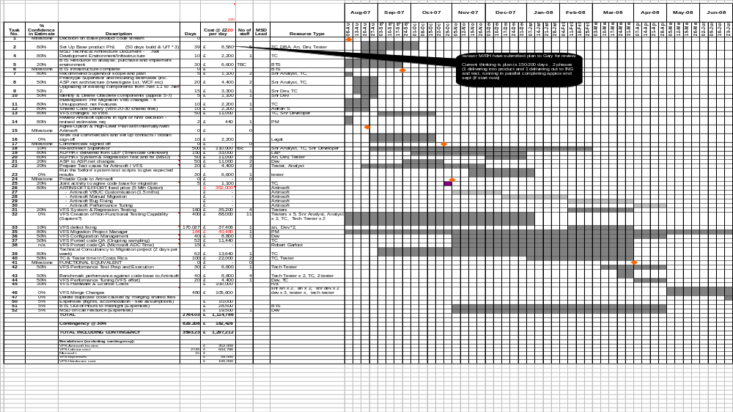

Appendix 3 - Omiga Technology Refresh Project Test Strategy

Insert Omiga Technology Refresh Project Test Strategy

Appendix 4 – Omiga Product Management Programme High Level Plan
